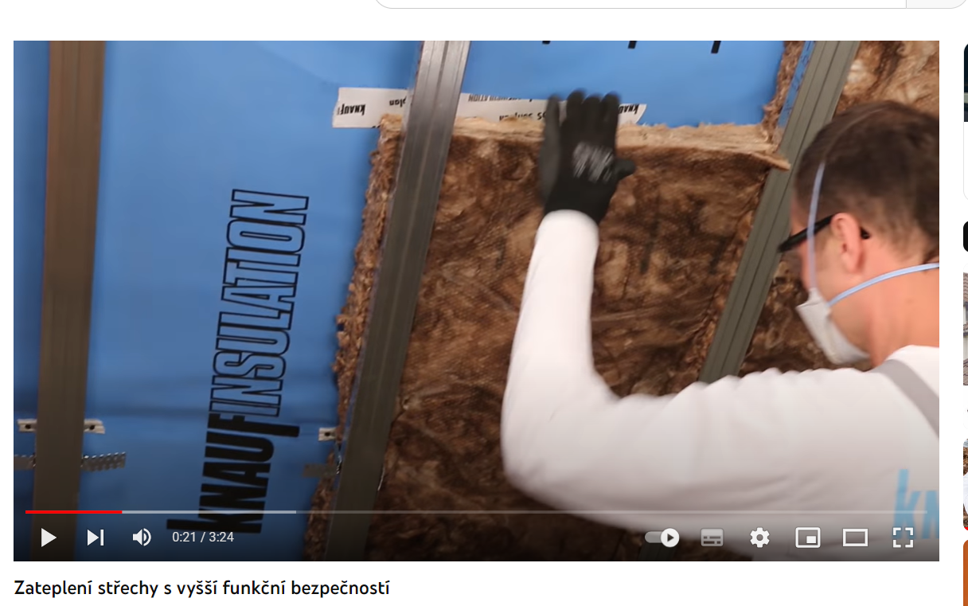
https://www.youtube.com/watch?v=3Y88lWPBBU4&t=5s

